**PIZZA SALES ANALYSIS USING SQL AND MS EXCEL**

**PROBLEM STATEMENT**: We are required to analyse the dataset and work according to the business stakeholders to know the insights of the data given by the client .

**KPIs Requirement**  
We need to analyze key indicators for our pizza sales data to gain insights into our business performance. Specifically , we want to calculate the following metrices:

1. Total Revenue : The sum of the total price of all pizza orders.
2. Average Order value : The average amount spent per order, calculated by dividing the total revenue by the total number of orders.
3. Total Pizzas Sold : The sum of quantities of all pizzas sold.

Total Orders : The total number of orders placed .

1. Average Pizzas per order : The average number of pizzas sold per order, calculated by dividing the total number of pizzas sold by the total number of orders .

**SOFTWARE USED :**

**MS OFFICE/EXCEL : Version 2021  
MS SQL SERVER 19.0  
SQL SERVER MANAGEMENT STUDIO -19.0.20209.0**

Steps performed :

1. Connecting to MS SQL SERVER : We will load the data into sql server and from there we will write queries to find out the insights of the data .
2. Data Cleaning : Data cleaning in Excel is the process of identifying and correcting errors, inconsistencies, and inaccuracies in your spreadsheet to ensure that the data is accurate, reliable, and suitable for analysis or reporting .
3. 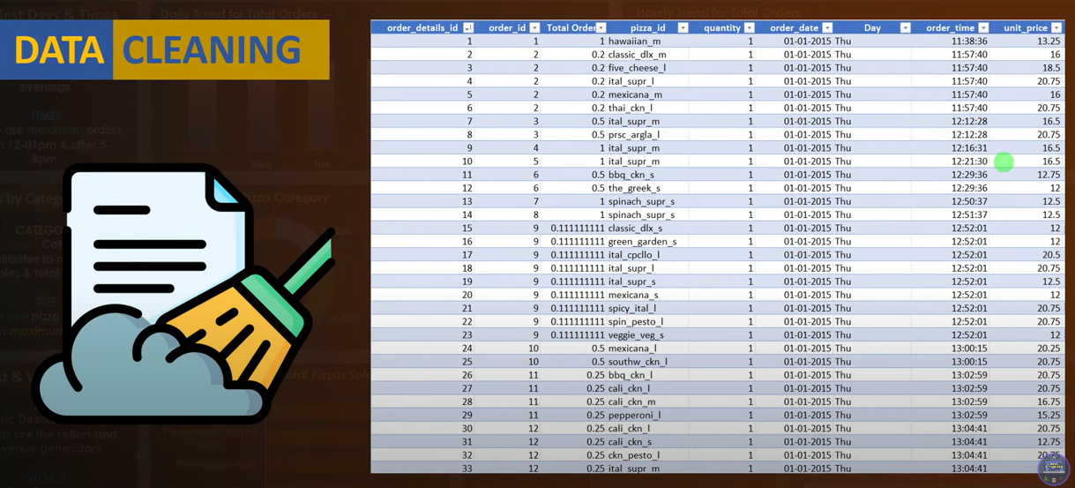

3 . Data processing in Excel involves various tasks to manipulate, analyze, and visualize data in order to extract meaningful insights or generate reports .

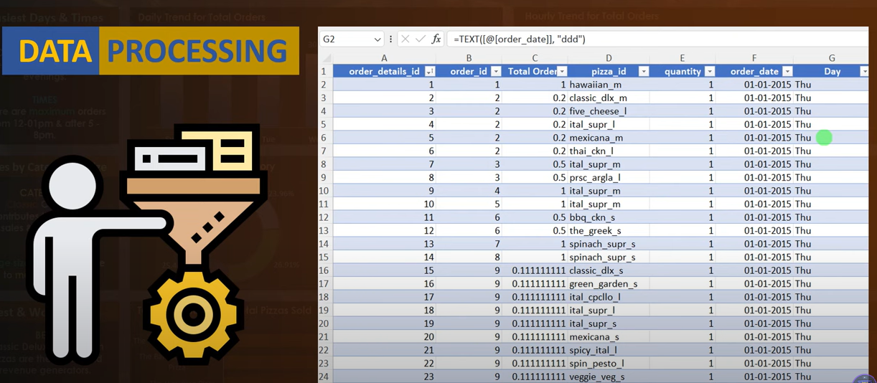

1. Data Analysis : Data analysis in Excel involves using the built-in features, functions, and tools to explore, summarize, and draw conclusions from your data.

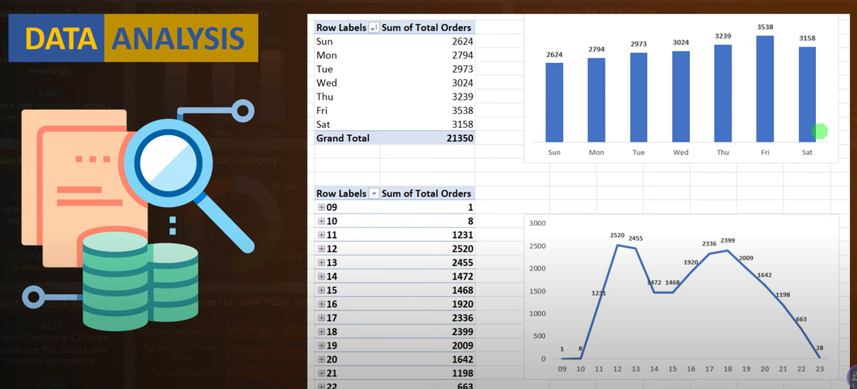

5. Data visualization is the process of representing data graphically to help individuals and organizations understand, interpret, and make decisions based on data. Excel provides a range of tools and features for creating effective data visualizations.

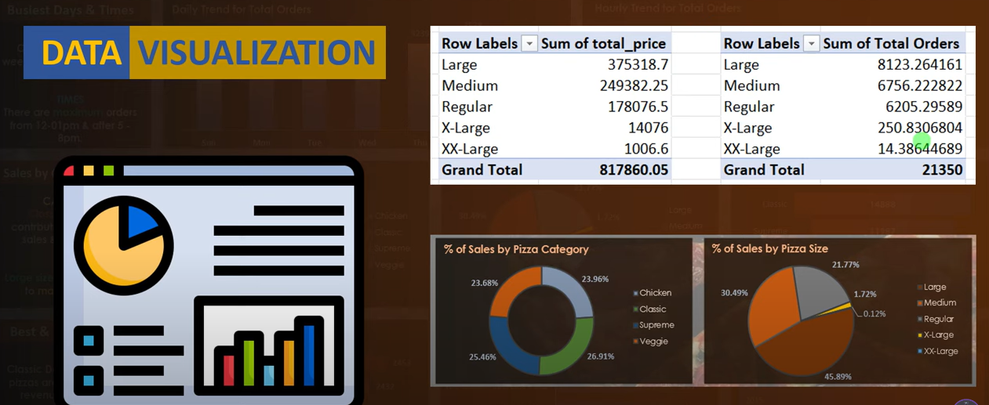

**CHARTS REQUIREMENT**We would like to visualize various aspects of our pizza sales data to gain insights and understand key trends. We have identified the following requirements for creating charts:

1. Daily trends for Total Orders :   
   Create a bar chart that displays the daily trend of total orders over a specific time period. This chart will help us identify any pattern or fluctuations in order volumes on a daily basis.
2. Hourly Trend for Total Orders :  
   Create a line chart that illustrates the hourly trend of total orders throughout the day. This chart will allow us to identify peak hours or periods of high order activity.
3. Percentage of Sales by Pizza Category :  
   Create a pie chart that shoes the distribution of sales across different pizza categories. This chart will provide insights into the popularity of various pizza categories and their contribution to overall sales.
4. Percentage of Sales by Pizza Size :  
   Generate a pie chart that represents the percentage of sales attributed to different pizza sizes. This chart will help us understand customer preferences for pizza sizes and their impact on sales.
5. Total Pizzas sold by Pizza category :  
   Create a funnel chart that represents the total number of pizzas sold for each pizza category. This chart will allow us to compare the sales performance of different pizza categories.
6. Top 5 best sellers by Pizza category:  
   Create a bar chart highlighting the top 5 best selling pizzas based on the total number of pizzas sold. This chart will help us identify the most popular pizza options .
7. Bottom 5 Worst sellers by Total pizzas sold:  
   Create a bar chart showcasing the bottom 5 worst selling pizzas based on the total number of pizzas sold. This chart will enable us to identify underperforming or less selling pizzas.

Final Dashboard View :

